**Name:** Harsh Chheda

**Roll Number:** 31031521005 / 22-15405

**Class:** Msc. Computer Science

**Subject**: Cloud Computing

**Year:** 2022-23

**Practical 7**

**Aim:** Implementation of Cloud services on Amazon web services.

**Code:**

# Setting up EC2 Key-Pairs

## Step 1: Go to [**Amazon EC2 Console**](https://ap-south-1.console.aws.amazon.com/ec2/home)

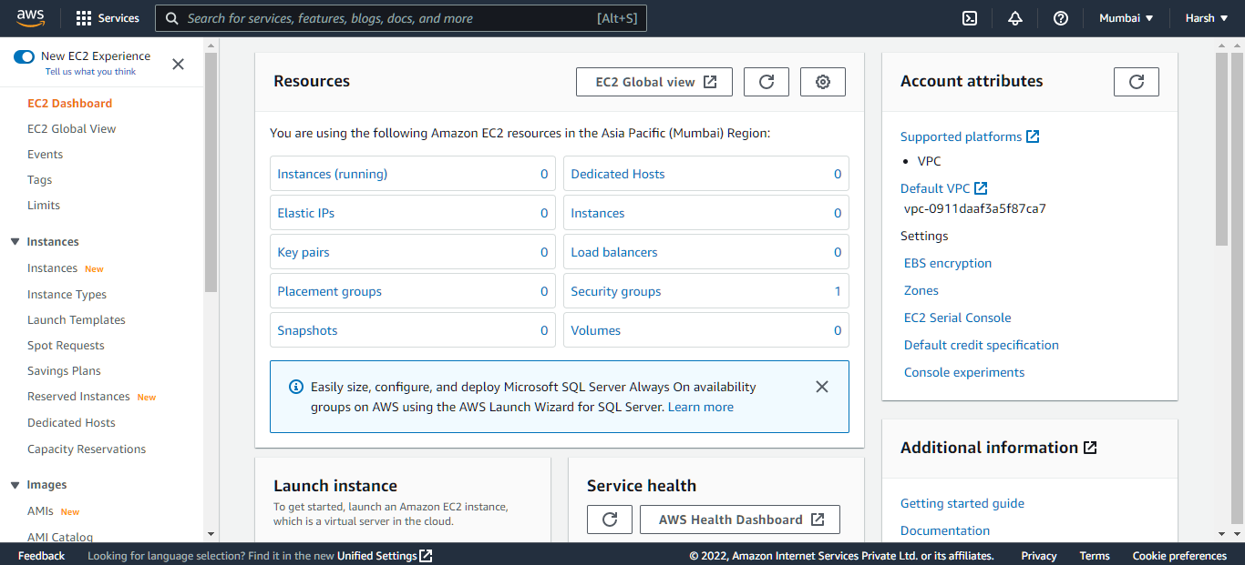

## Step 2: In the Navigation pane, click Key Pairs under Network and Security Section

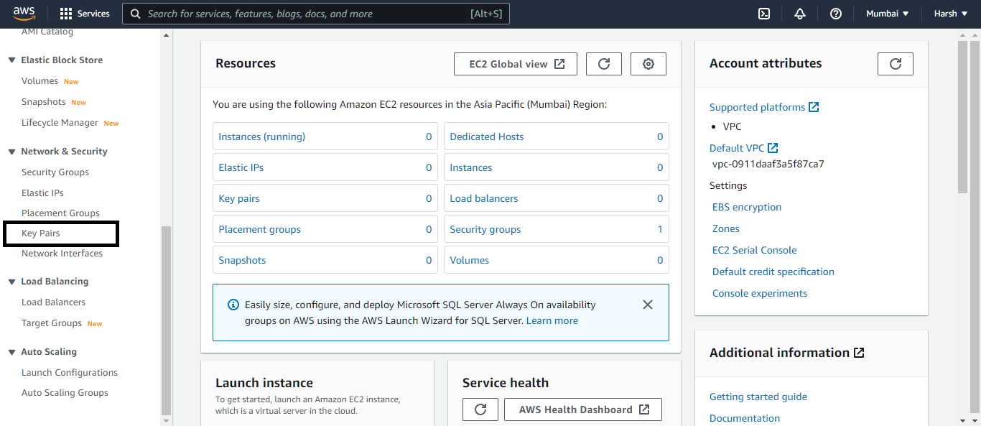

## Step 3: On the Key Pairs page, click Create Key Pair

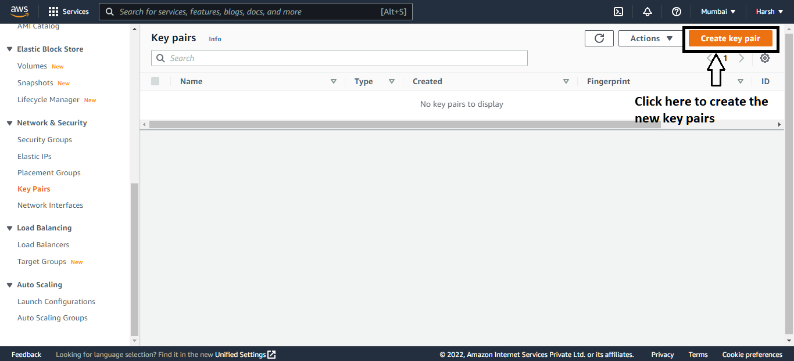

## Step 4: In the Create Key Pair dialog box, enter a name for your key pair, such as, mykeypair

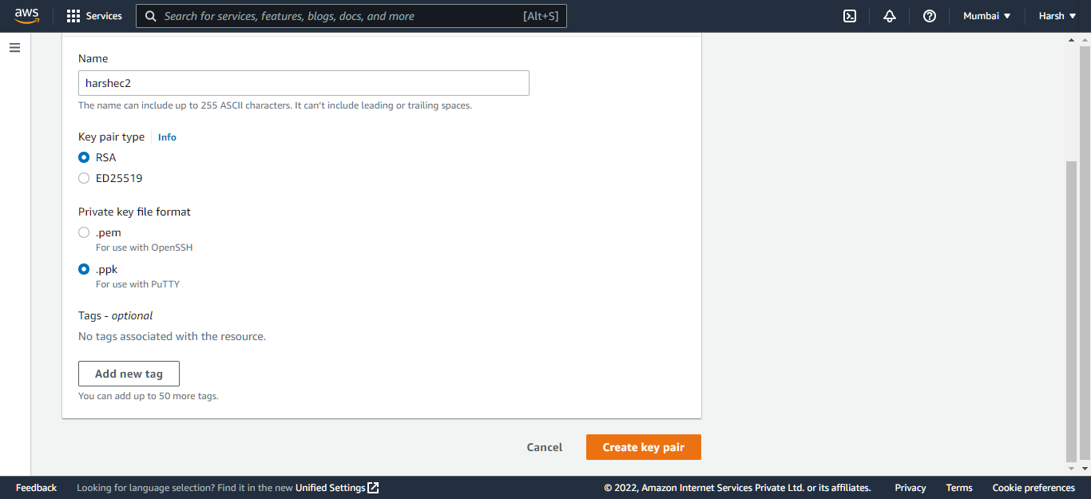

## Step 5: Click Create key Pair

## Step 6: Save the resulting PEM file in a safe location

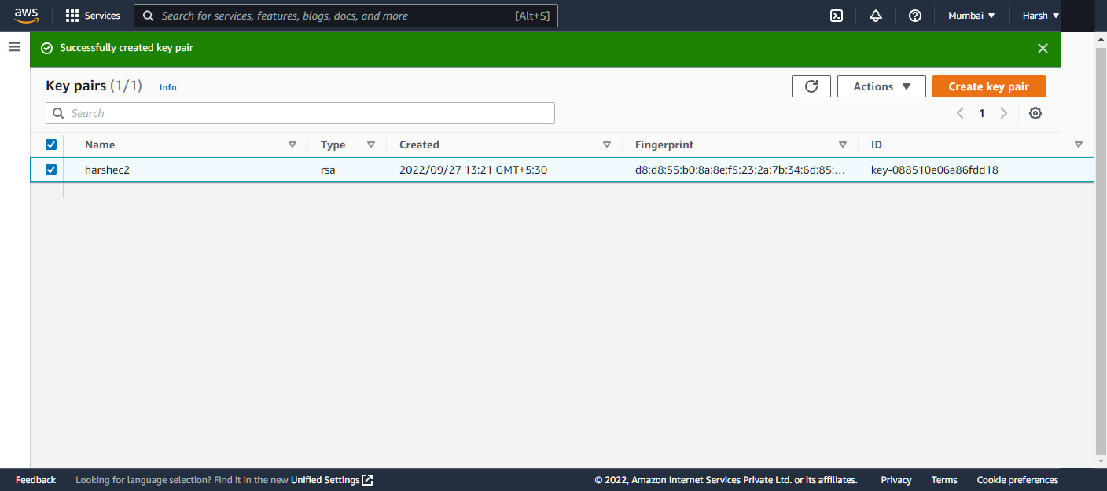

# Setting up your environment on Amazon EC2

## Step 1: Sign in to the AWS console and search EC2.

'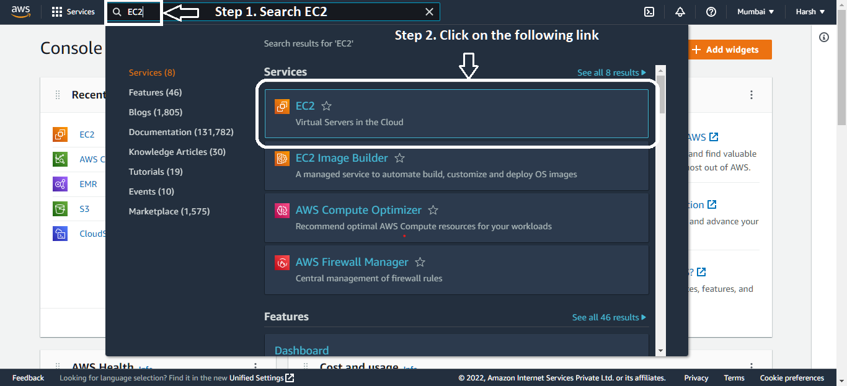

## Step 2: Create new Instance

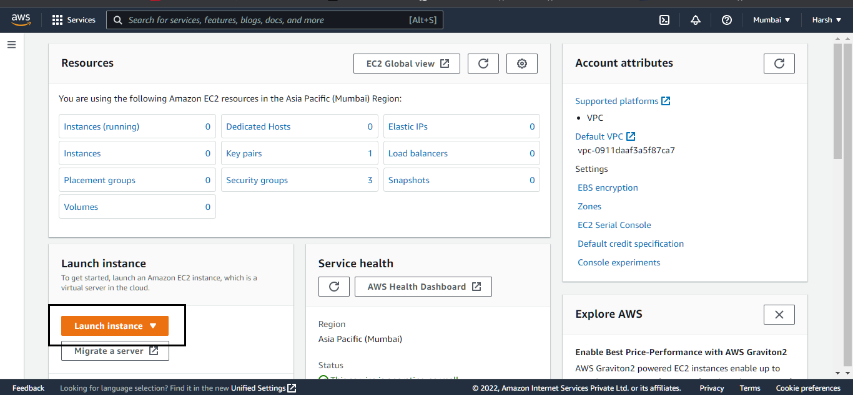

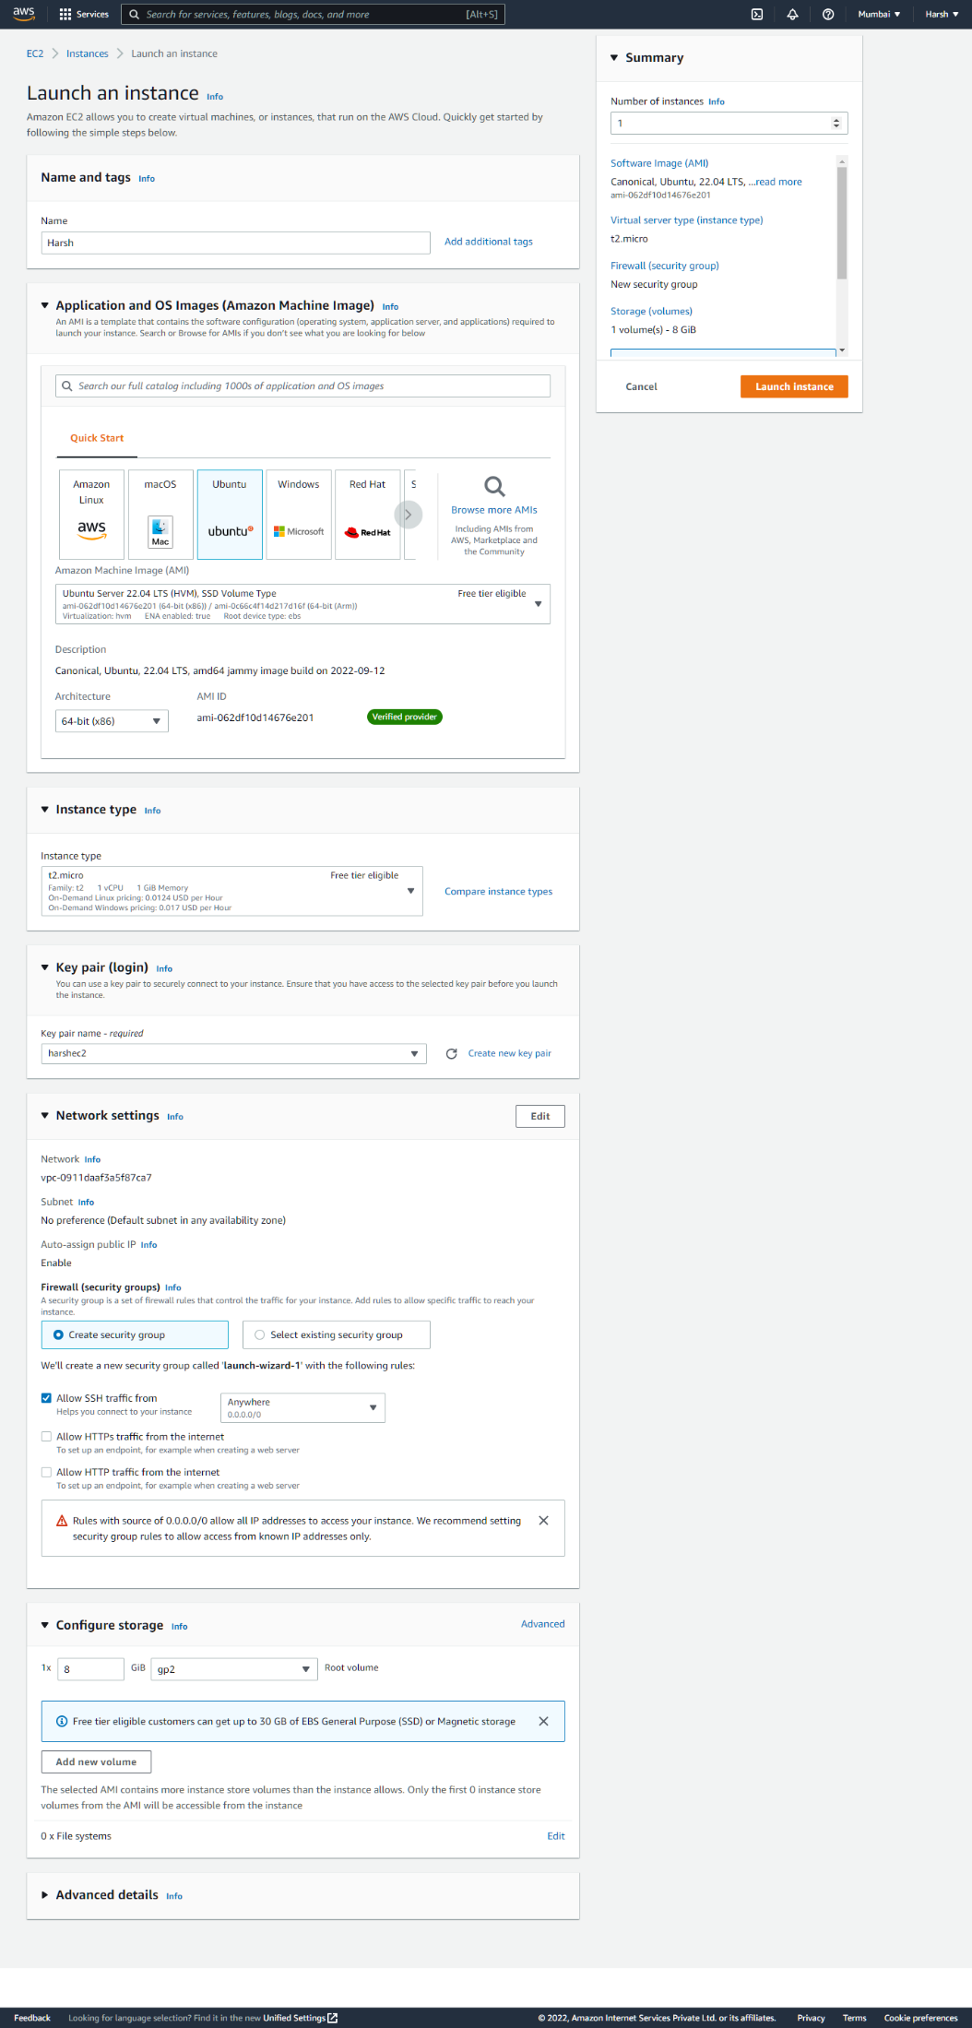

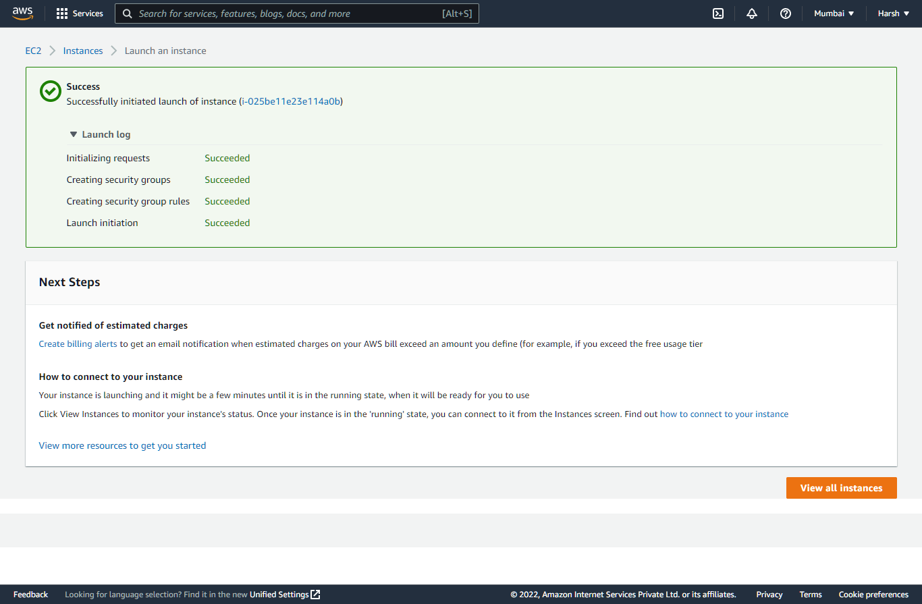

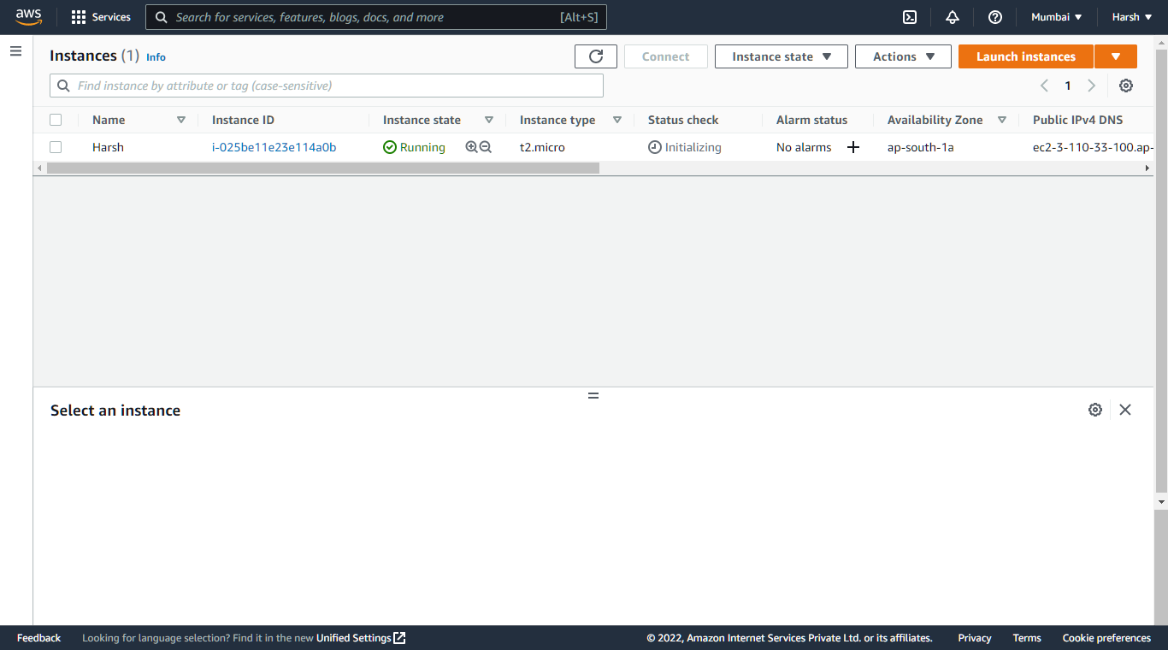

## Step 3: Start the instance

